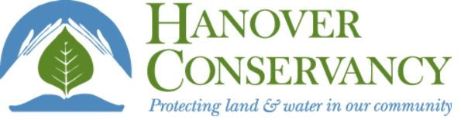
Balch Hill Quest
------------------------------------------------------------
Meet at Grasse Road and you will see
A brand new quest for you and me!

Leave the dirt lot and cross the street,
The kiosk is where we all will meet.
In groups or in pairs, be sure to take care
As we climb Balch Hill to find our treat.

Keep walking uphill until you see
Stone walls, and barbed wire now stuck in the trees.
The Chapman Trail starts here, so sharpen your sight;
Follow its blue blazes just off to your right.

This newest trail’s named for our friends Rob and Jan
Who love this great hill and surrounding land.
They’ve started a challenge for neighbors, too,
To give towards the upkeep of all these great views.

Another trail joins at the end of this one:
Turn left and keep walking for more hiking fun.
At the sign for Grasse Road Trail, turn right and go down
Across a small bridge just above muddy ground.

Wind your way past a trident made from a tree
(It’s standing, not hollow and it splits into three).
As it starts to get brighter, we know we draw near
To the meadow with breezes and birdsongs to hear.

Here we are now at the end of our trek
(In summer up here, do lots of tick checks).
In winter, look for the tall Baker Tower;
In summer, enjoy all the birds, bees and flowers.

A circle of apple trees tells of farms past
Now they provide food for wildlife, called “mast”.
Your own picnic spot can be easily found
Beneath the big maple, on benches or ground.

This land was once to be dozens of condos
Until the developer heard all the “Oh no!”s.
Now owned by the College, the Town and Conservancy,
Our Hill will forever stay open and free.
Balch Hill Quest
------------------------------------------------------------
Meet at Grasse Road and you will see
A brand new quest for you and me!

Leave the dirt lot and cross the street,
The kiosk is where we all will meet.
In groups or in pairs, be sure to take care
As we climb Balch Hill to find our treat.

Keep walking uphill until you see
Stone walls, and barbed wire now stuck in the trees.
The Chapman Trail starts here, so sharpen your sight;
Follow its blue blazes just off to your right.

This newest trail’s named for our friends Rob and Jan
Who love this great hill and surrounding land.
They’ve started a challenge for neighbors, too,
To give towards the upkeep of all these great views.

Another trail joins at the end of this one:
Turn left and keep walking for more hiking fun.
At the sign for Grasse Road Trail, turn right and go down
Across a small bridge just above muddy ground.

Wind your way past a trident made from a tree
(It’s standing, not hollow and it splits into three).
As it starts to get brighter, we know we draw near
To the meadow with breezes and birdsongs to hear.

Here we are now at the end of our trek
(In summer up here, do lots of tick checks).
In winter, look for the tall Baker Tower;
In summer, enjoy all the birds, bees and flowers.

A circle of apple trees tells of farms past
Now they provide food for wildlife, called “mast”.
Your own picnic spot can be easily found
Beneath the big maple, on benches or ground.

This land was once to be dozens of condos
Until the developer heard all the “Oh no!”s.
Now owned by the College, the Town and Conservancy,
Our Hill will forever stay open and free.

